Essay beginnings and endings

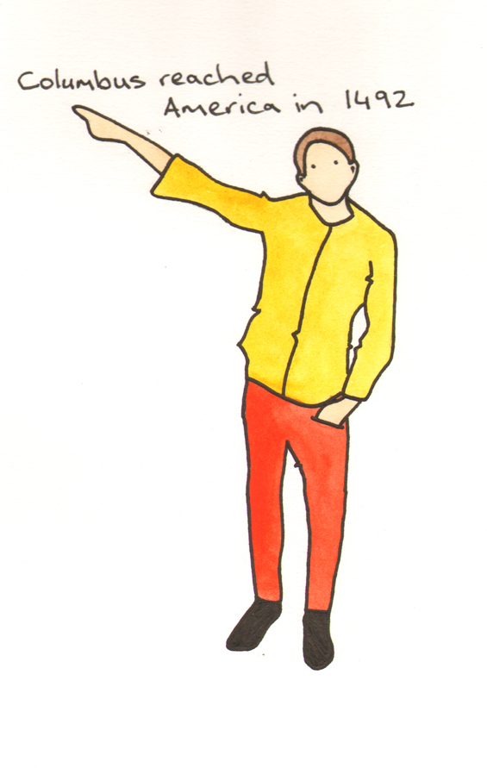

Useful sentences to begin your writing.
The Academic Phrasebank http://www.phrasebank.manchester.ac.uk/introductions.htm
is a general resource for academic writers provided by the University of Manchester. It aims to provide you with examples of some useful phrases which might kick start your writing / thinking.

The Phrasebank covers topics such as :
Introducing Work.
Referring to the Literature.
Being Critical.
Describing Methods.
Reporting Results.
Discussing Findings.
Writing Conclusions.
General Functions.
This leaflet contains some of the useful phrases for introducing and concluding your work.

Introductions.

Establishing the importance of the topic:

One of the most significant current discussions in legal and moral philosophy is ......
It is becoming increasingly difficult to ignore the .....
X is the leading cause of death in western industrialised countries.
X is a common disorder characterised by ......
X is an important component in the climate system, and plays a key role in Y.
In the new global economy, X has become a central issue for ......
In the history of development economics, X has been thought of as a key factor in .......
X is an increasingly important area in applied linguistics.
Central to the entire discipline of X is the concept of .......
X is at the heart of our understanding of ......

Establishing the importance of the topic (time frame given):

Recent developments in X have heightened the need for ......
In recent years, there has been an increasing interest in ......
Recent developments in the field of X have led to a renewed interest in ......
Recently, researchers have shown an increased interest in ......
The past decade has seen the rapid development of X in many .......
The past thirty years have seen increasingly rapid advances in the field of......
Over the past century there has been a dramatic increase in ......
One of the most important events of the 1970s was ......
Traditionally, Xs have subscribed to the belief that ......
X proved an important literary genre in the early Y community.
The changes experienced by Xs over the past decade remain unprecedented.

Focus, aim, argument:

This paper will focus on/examine/give an account of ......
This essay seeks to remedy these problems by analyisng the literature of ......
The objectives of this research are to determine whether ......
This paper seeks to address the following questions:
This essay critically examines/discusses/traces ......
The purpose of this paper is to review recent research into the ......
This paper will review the research conducted on ......
This chapter reviews the literature concerning the usefulness of using ......
The aim of this paper is to determine/examine ......
The aim of this study was to evaluate and validate .....
In the pages that follow, it will be argued that ……
This paper attempts to show that ......

Outline of structure:

The main questions/issues addressed in this paper are: a), b and c).
This paper has been divided into four parts. The first part deals with ......
The essay has been organised in the following way.
This paper first gives a brief overview of the recent history of X.
This paper begins by ...... It will then go on to ......
The first section of this paper will examine ......
Chapter 2 begins by laying out the theoretical dimensions of the research, and looks at how ......
Chapter 3 describes the design, synthesis, characterization and evaluation of

Conclusions.

Summarising the content:

This paper has given an account of and the reasons for the widespread use of X ......
This essay has argued that X is the best instrument to ......
This assignment has explained the central importance of X in Y.
This dissertation has investigated ......
Restatement of aims (research):
This study set out to determine ......
The present study was designed to determine the effect of .......
In this investigation, the aim was to assess ......
The purpose of the current study was to determine ......
This project was undertaken to design ...... and evaluate .....
Returning to the hypothesis/question posed at the beginning of this study, it is now possible to state that .....

Summarising the findings (research):
This study has shown that ......
These findings suggest that in general ......
One of the more significant findings to emerge from this study is that .....
It was also shown that......
This study has found that generally .......
The following conclusions can be drawn from the present study ......
The relevance of X is clearly supported by the current findings.
This study/research has shown that ......
The second major finding was that ........
The results of this investigation show that .......
The most obvious finding to emerge from this study is that ......
X, Y and Z emerged as reliable predictors of ......
Multiple regression analysis revealed that the ......

Suggesting implications:
The evidence from this study suggests that ......
The results of this study indicate that ......
The results of this research support the idea that .......
In general, therefore, it seems that ......
Taken together, these results suggest that ......
An implication of this is the possibility that ......
The findings of this study suggest that ......

